AI LAB 1
EXPERIMENT 1 - BFS for Emergency Facility Navigation
AIM: To find a route through a hospital or emergency facility.
QUESTION:
Develop a Python-based navigation system for an emergency response team operating inside a hospital represented as an unweighted graph. Rooms and junctions are vertices, while accessible corridors are edges. Implement Breadth-First Search (BFS) to identify the route from the emergency entrance to a designated critical-care unit.
The program must:
- Represent the hospital layout as an adjacency list.
- Accept the source and destination nodes.
- Find and display the shortest route in terms of the number of corridors traversed.
- Report the number of nodes explored and explain how BFS guarantees a shortest path in an unweighted graph.

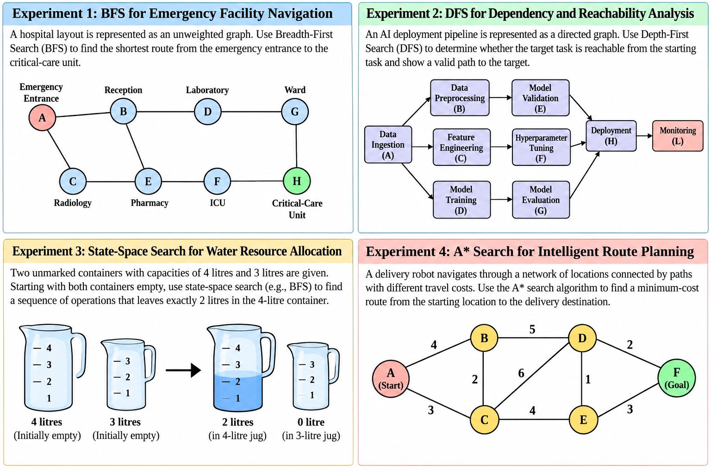
CODE:
from collections import deque

# Hospital layout represented as an adjacency list
graph = {
'A': ['B', 'C'],
'B': ['A', 'D', 'E'],
'C': ['A', 'E'],
'D': ['B', 'G'],
'E': ['B', 'C', 'F'],
'F': ['E', 'H'],
'G': ['D', 'H'],
'H': ['F', 'G']
}

def bfs(graph, source, destination):
queue = deque([(source, [source])])
visited = {source}
explored = 0

while queue:
node, path = queue.popleft()
explored += 1

if node == destination:
print("Shortest route:", " -> ".join(path))
print("Corridors traversed:", len(path) - 1)
print("Nodes explored:", explored)
return

for neighbor in graph[node]:
if neighbor not in visited:
visited.add(neighbor)
queue.append((neighbor, path + [neighbor]))

print("No route found.")

source = input("Enter source node (A-H): ").upper()
destination = input("Enter destination node (A-H): ").upper()

if source in graph and destination in graph:
bfs(graph, source, destination)
else:
print("Invalid node! Enter a node from A to H.")

OUTPUT:
Enter source node (A-H): A
Enter destination node (A-H): H
Shortest route: A -> B -> D -> G -> H
Corridors traversed: 4
Nodes explored: 8

EXPERIMENT 2 - DFS for Dependency and Reachability Analysis
AIM: To analyse dependencies in an AI software pipeline.
QUESTION:
An AI deployment pipeline consists of interconnected processing tasks, where each task depends on one or more downstream tasks. Model the pipeline as a directed graph and implement Depth-First Search (DFS) in Python to determine whether a specified target task is reachable from a given starting task.
The program must:
- Represent the pipeline using a directed adjacency list.
- Accept a starting task and a target task.
- Display the DFS traversal order and determine whether the target is reachable.
- Reconstruct a valid path to the target, if one exists.
- Explain how visited-node tracking prevents repeated exploration and how DFS behaves when the graph contains cycles.

CODE:

# Directed graph representing the AI deployment pipeline
graph = {
'A': ['B', 'C', 'D'],
'B': ['E'],
'C': ['F'],
'D': ['G'],
'E': ['H'],
'F': ['H'],
'G': ['H'],
'H': ['L'],
'L': []
}

def dfs(graph, start, target):
visited = set()
path = []
traversal = []

def search(node):
visited.add(node)
traversal.append(node)
path.append(node)

if node == target:
return True

for neighbor in graph[node]:
if neighbor not in visited:
if search(neighbor):
return True

path.pop()
return False

found = search(start)

print("DFS Traversal:", " -> ".join(traversal))

if found:
print("Target is reachable.")
print("Path:", " -> ".join(path))
else:
print("Target is not reachable.")

start = input("Enter starting task (A, B, C, D, E, F, G, H, L): ").upper()
target = input("Enter target task (A, B, C, D, E, F, G, H, L): ").upper()

if start in graph and target in graph:
dfs(graph, start, target)
else:
print("Invalid task!")

OUTPUT:
Enter starting task (A, B, C, D, E, F, G, H, L): A
Enter target task (A, B, C, D, E, F, G, H, L): H
DFS Traversal: A -> B -> E -> H
Target is reachable.
Path: A -> B -> -> H
EXPERIMENT 3 - State-Space Search for Water Resource Allocation
AIM: To Measure a target quantity using containers with fixed capacities.
QUESTION:
Design a Python-based state-space search solution for a water allocation problem involving two unmarked containers with capacities of 4 litres and 3 litres. Starting with both containers empty, determine a sequence of valid operations that leaves exactly 2 litres in the 4-litre container.
The program must:
- Represent each state as the quantities of water in both containers.
- Define the legal actions: fill, empty and transfer water between containers.
- Search the state space using BFS and identify a valid solution.
- Display the sequence of states and actions from the initial state to the goal.
- Explain how state representation, goal testing and repeated-state detection affect the search.
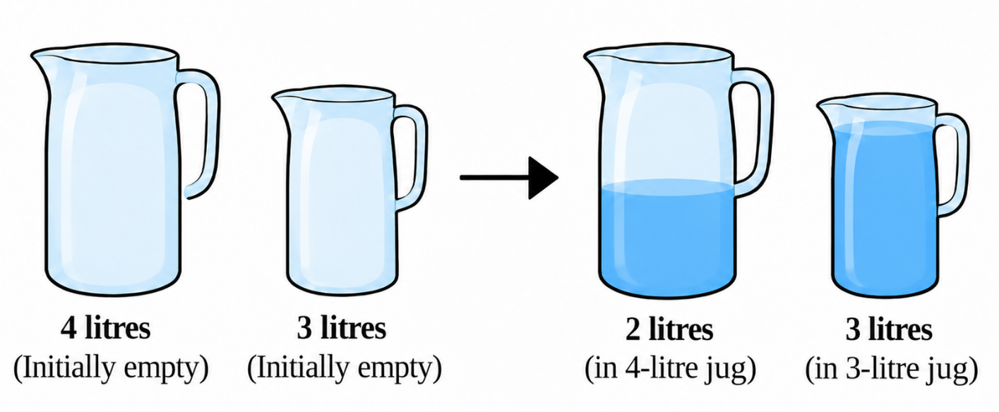

CODE:
from collections import deque

def get_next_states(state):
x, y = state
states = []

# Fill the 4-litre jug
states.append(((4, y), "Fill 4-litre jug"))

# Fill the 3-litre jug
states.append(((x, 3), "Fill 3-litre jug"))

# Empty the 4-litre jug
states.append(((0, y), "Empty 4-litre jug"))

# Empty the 3-litre jug
states.append(((x, 0), "Empty 3-litre jug"))

# Pour 4-litre jug into 3-litre jug
pour = min(x, 3 - y)
states.append(((x - pour, y + pour),
"Pour 4-litre jug into 3-litre jug"))

# Pour 3-litre jug into 4-litre jug
pour = min(y, 4 - x)
states.append(((x + pour, y - pour),
"Pour 3-litre jug into 4-litre jug"))

return states

def bfs():
start = (0, 0)
queue = deque([(start, [])])
visited = {start}

while queue:
state, path = queue.popleft()

# Goal: exactly 2 litres in the 4-litre jug
if state[0] == 2:
print("Solution found!")
print("Initial state:", start)

for action, next_state in path:
print(action, "->", next_state)

print("Goal state:", state)
return

for next_state, action in get_next_states(state):
if next_state not in visited:
visited.add(next_state)
queue.append(
(next_state, path + [(action, next_state)])
)

print("No solution found.")

bfs()

OUTPUT:
Solution found!
Initial state: (0, 0)
Fill 4-litre jug -> (4, 0)
Pour 4-litre jug into 3-litre jug -> (1, 3)
Empty 3-litre jug -> (1, 0)
Pour 4-litre jug into 3-litre jug -> (0, 1)
Fill 4-litre jug -> (4, 1)
Pour 4-litre jug into 3-litre jug -> (2, 3)
Goal state: (2, 3)

EXPERIMENT 4 - A* Search for Intelligent Route Planning
APPLICATION: To route planning for an autonomous delivery robot.
QUESTION
Develop an intelligent route-planning system for an autonomous delivery robot navigating a network of locations connected by paths with different travel costs. Implement the A* search algorithm in Python to find a minimum-cost route from a specified starting location to a delivery destination.
The program must:
- Represent the environment as a weighted graph.
- Assign a heuristic estimate \(h(n)\) to each node and calculate the accumulated path cost \(g(n)\).
- Use \(f(n)=g(n)+h(n)\) to determine which node to explore next.
- Display the selected route, total path cost and node expansion order.
- Explain how heuristic quality affects search efficiency and why an admissible heuristic matters for optimality.
Heuristic values.
Node | h(n)
A | 6
B | 4
C | 5
D | 2
E | 3
F | 0

CODE:
import heapq

# Weighted graph representing the locations
graph = {
'A': {'B': 4, 'C': 3},
'B': {'A': 4, 'C': 2, 'D': 5},
'C': {'A': 3, 'B': 2, 'D': 6, 'E': 4},
'D': {'B': 5, 'C': 6, 'E': 1, 'F': 2},
'E': {'C': 4, 'D': 1, 'F': 3},
'F': {'D': 2, 'E': 3}
}

# Admissible heuristic estimates to goal F
h = {
'A': 6,
'B': 4,
'C': 4,
'D': 2,
'E': 2,
'F': 0
}

def astar(start, goal):
queue = [(h[start], 0, start)]
parent = {}
cost = {start: 0}
expanded = []

while queue:
f, g, node = heapq.heappop(queue)

if g != cost[node]:
continue

expanded.append(node)

if node == goal:
path = []
current = goal

while current != start:
path.append(current)
current = parent[current]

path.append(start)
path.reverse()

print("Selected route:", " -> ".join(path))
print("Total path cost:", cost[goal])
print("Node expansion order:", " -> ".join(expanded))
return

for neighbor, weight in graph[node].items():
new_cost = g + weight

if new_cost < cost.get(neighbor, float('inf')):
cost[neighbor] = new_cost
parent[neighbor] = node
f_value = new_cost + h[neighbor]

heapq.heappush(
queue, (f_value, new_cost, neighbor)
)

print("No route found.")

start = input("Enter start node (A-F): ").upper()
goal = input("Enter goal node (A-F): ").upper()

if start in graph and goal in graph:
astar(start, goal)
else:
print("Invalid node!")

OUTPUT:
Optimal path : A -> C -> E -> F
Total path cost : 10
Nodes expanded : 6
Expansion order : A -> B -> C -> E -> D -> F

Experiment 5: Solving the 8-Queens Problem Using Backtracking
AIM: To find the collision-free placement of components on a grid.
QUESTION:
An automated placement system must position eight components on an 8 × 8 grid such that no two components interfere with one another. Model this as the 8-Queens problem, where each queen represents a component and can attack another queen along the same row, column, or diagonal.
Develop a Python program using the backtracking algorithm to find a valid arrangement of eight queens on the chessboard.
The program must:
- Represent the chessboard as an 8 × 8 grid and track the positions of the queens.
- Place one queen at a time while ensuring that no two queens share the same row, column, or diagonal.
- Use recursive backtracking to undo an invalid placement and explore alternative positions.
- Display the final chessboard arrangement and the positions of all eight queens.
- Report the number of placement attempts and explain how constraint checking and backtracking help find a valid solution.

CODE:
N = 8

# Store the column position of each queen
board = [-1] * N

attempts = 0

# Function to check whether a queen can be placed safely
def is_safe(row, col):
for i in range(row):
# Check same column
if board[i] == col:
return False

# Check diagonal attacks
if abs(board[i] - col) == abs(i - row):
return False

return True

# Recursive backtracking function
def solve(row):
global attempts

# All eight queens are placed
if row == N:
return True

# Try placing queen in each column
for col in range(N):
attempts += 1

if is_safe(row, col):
board[row] = col

# Recursively place the next queen
if solve(row + 1):
return True

# Backtrack if no solution is found
board[row] = -1

return False

# Execute the algorithm
if solve(0):
print("Valid 8-Queens Solution:\n")

# Display chessboard
for row in range(N):
for col in range(N):
if board[row] == col:
print(" Q ", end="")
else:
print(" . ", end="")
print()

# Display queen positions
print("\nQueen Positions:")
for row in range(N):
print(f"Queen {row + 1}: Row {row + 1}, Column {board[row] + 1}")

print("\nTotal Placement Attempts:", attempts)

else:
print("No solution exists.")

OUTPUT:
Valid 8-Queens Solution:

Q . . . . . . .
. . . . Q . . .
. . . . . . . Q
. . . . . Q . .
. . Q . . . . .
. . . . . . Q .
. Q . . . . . .
. . . Q . . . .

Queen Positions:
Queen 1: Row 1, Column 1
Queen 2: Row 2, Column 5
Queen 3: Row 3, Column 8
Queen 4: Row 4, Column 6
Queen 5: Row 5, Column 3
Queen 6: Row 6, Column 7
Queen 7: Row 7, Column 2
Queen 8: Row 8, Column 4

Total Placement Attempts: 876

Experiment 6: Solving the Map Colouring Problem Using CSP
AIM: To make frequency allocation for neighbouring cellular network regions.
QUESTION:
A telecommunications network is divided into interconnected regions. To reduce interference, neighbouring regions must be assigned different frequency bands. Model the network as a Constraint Satisfaction Problem (CSP), where each region is a variable, the available frequency bands form its domain, and neighbouring regions must receive different assignments.
Develop a Python program to solve the map-colouring problem using CSP techniques.
The program must:
- Represent each region as a variable and define its available colours as a domain.
- Specify adjacency constraints requiring neighbouring regions to have different colours.
- Use backtracking search to find a valid colour assignment.
- Display the final map-colouring assignment and verify that all adjacency constraints are satisfied.
- Report the number of assignments attempted and explain how CSP variables, domains, and constraints guide the search.
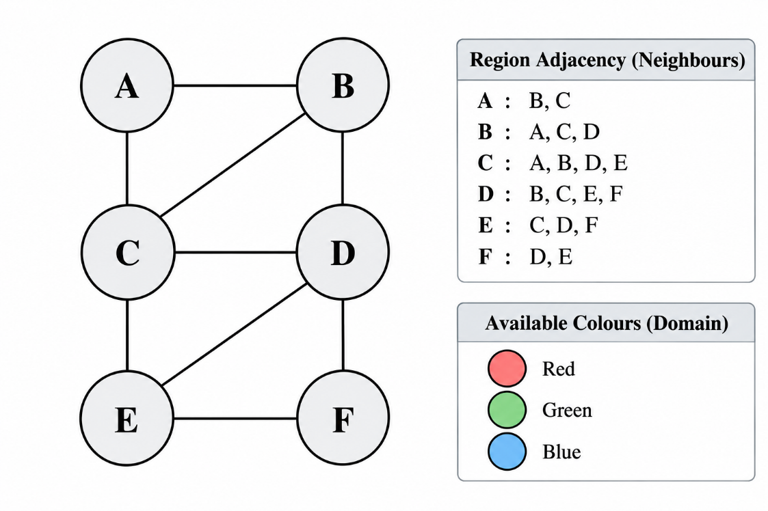

CODE:
# 1. Define CSP variables (regions)
regions = ['A', 'B', 'C', 'D', 'E', 'F']

# 2. Define available colours (domains)
colours = ['Red', 'Green', 'Blue']

domains = {
region: colours.copy() for region in regions
}

# 3. Define adjacency constraints
neighbours = {
'A': ['B', 'C'],
'B': ['A', 'C', 'D'],
'C': ['A', 'B', 'D', 'E'],
'D': ['B', 'C', 'E', 'F'],
'E': ['C', 'D', 'F'],
'F': ['D', 'E']
}

# Store colour assignments
assignment = {}

# Count assignment attempts
attempts = 0

# Check whether a colour is valid
def is_valid(region, colour):
for neighbour in neighbours[region]:
if neighbour in assignment:
if assignment[neighbour] == colour:
return False
return True

# 4. Backtracking search
def backtrack():
global attempts

# Check whether all regions are coloured
if len(assignment) == len(regions):
return True

# Select an unassigned region
region = next(r for r in regions if r not in assignment)

# Try each colour in its domain
for colour in domains[region]:
attempts += 1

if is_valid(region, colour):
assignment[region] = colour

if backtrack():
return True

# Backtrack
del assignment[region]

return False

# 5. Execute CSP algorithm
if backtrack():
print("Valid Map Colouring Assignment:\n")

for region in regions:
print(f"Region {region} : {assignment[region]}")

# Verify adjacency constraints
print("\nConstraint Verification:")

valid = True

for region in regions:
for neighbour in neighbours[region]:
if assignment[region] == assignment[neighbour]:
valid = False
print(f"Conflict between {region} and {neighbour}")

if valid:
print("All adjacency constraints are satisfied.")

print("\nTotal Assignment Attempts:", attempts)

else:
print("No valid colouring exists.")
OUTPUT:
Valid Map Colouring Assignment:

Region A : Red
Region B : Green
Region C : Blue
Region D : Red
Region E : Green
Region F : Blue

Constraint Verification:
All adjacency constraints are satisfied.

Total Assignment Attempts: 12

Experiment 7 - Implementing the Minimax Algorithm
AIM: To demonstrate decision-making in a two-player strategy game.
QUESTION:
A game-playing AI must select its best move in a two-player game where one player tries to maximize the score while the opponent tries to minimize it.
Develop a Python program to implement the Minimax algorithm for a game represented as a binary game tree. The program must:
- Represent the game tree with terminal utility values.
- Treat the AI as the maximizing player and the opponent as the minimizing player.
- Recursively evaluate the game tree using the Minimax algorithm.
- Display the evaluated values and the best move selected by the AI.
- Explain how the algorithm assumes that both players choose optimal moves.

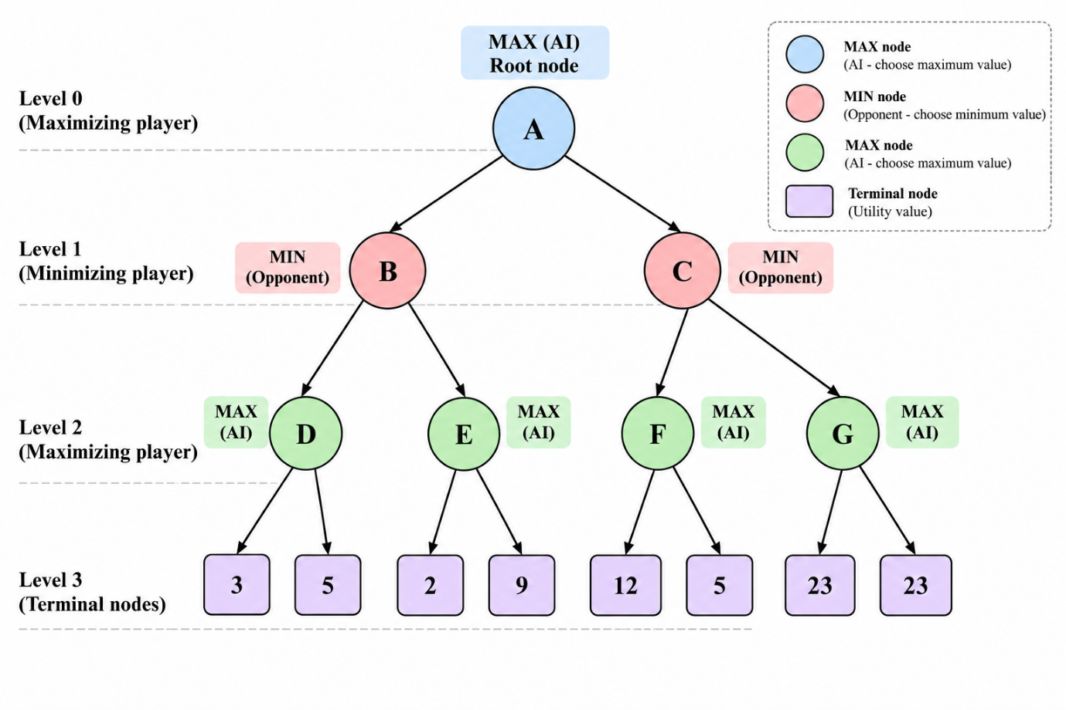

CODE:
# Binary game tree with terminal utility values
tree = [
[3, 5],
[2, 9]
]

def minimax(node, maximizing):
if isinstance(node, int):
return node

if maximizing:
values = [minimax(child, False) for child in node]
result = max(values)
print("Max values:", values, "->", result)
return result
else:
values = [minimax(child, True) for child in node]
result = min(values)
print("Min values:", values, "->", result)
return result

best_value = minimax(tree, True)

print("\nBest value for AI:", best_value)
print("Best move: First branch (left)")

OUTPUT:
Min values: [3, 5] -> 3
Min values: [2, 9] -> 2
Max values: [3, 2] -> 3

Best value for AI: 3
Best move: First branch (left)

Experiment 8 - Implementing Alpha-Beta Pruning
AIM: To optimize decision-making in a two-player strategy game.
QUESTION:
A chess-playing AI evaluates possible moves by exploring a game tree. Since evaluating every possible move is computationally expensive, the AI uses Alpha-Beta Pruning to eliminate branches that cannot influence the final decision.
Develop a Python program to implement the Alpha-Beta Pruning algorithm for a chess-inspired game tree with multiple possible moves and terminal utility values.
The program must:
- Represent the game tree with multiple candidate moves and terminal utility values.
- Implement Alpha-Beta Pruning using alpha and beta bounds.
- Identify and skip branches that cannot affect the final decision.
- Display the selected move, its utility value, the number of nodes evaluated, and the number of branches pruned.
- Explain how Alpha-Beta Pruning reduces the search effort while preserving the optimal decision.

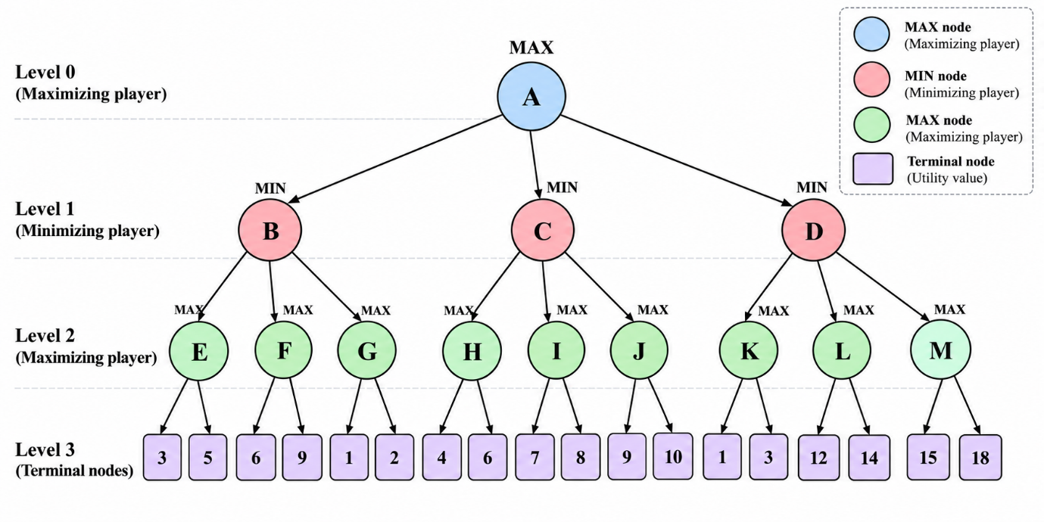

CODE:
tree = [
[3, 5],
[2, 9]
]

nodes_evaluated = 0
branches_pruned = 0

def alpha_beta(node, alpha, beta, maximizing):
global nodes_evaluated, branches_pruned

if isinstance(node, int):
nodes_evaluated += 1
print("Evaluating:", node)
return node

if maximizing:
value = float('-inf')

for i, child in enumerate(node):
value = max(value, alpha_beta(child, alpha, beta, False))
alpha = max(alpha, value)

if alpha >= beta:
branches_pruned += len(node) - i - 1
print("Pruned remaining branches:", len(node) - i - 1)
break

return value

else:
value = float('inf')

for i, child in enumerate(node):
value = min(value, alpha_beta(child, alpha, beta, True))
beta = min(beta, value)

if beta <= alpha:
branches_pruned += len(node) - i - 1
print("Pruned remaining branches:", len(node) - i - 1)
break

return value

best_value = alpha_beta(tree, float('-inf'),
float('inf'), True)

print("\nBest value for AI:", best_value)
print("Best move: First branch (left)")
print("Nodes evaluated:", nodes_evaluated)
print("Branches pruned:", branches_pruned)

OUTPUT:
Evaluating: 3
Evaluating: 5
Evaluating: 2
Pruned remaining branches: 1

Best value for AI: 3
Best move: First branch (left)
Nodes evaluated: 3
Branches pruned: 1

EXPERIMENT 9 - Forward Chaining
AIM: To implement forward chaining using rule-based medical appointment eligibility.
QUESTION:
A healthcare appointment system uses facts and logical rules to determine whether a patient is eligible for a priority consultation. The system derives new facts from existing information by repeatedly applying rules until a conclusion is reached or no further facts can be inferred.
Develop a Python program to implement Forward Chaining using facts and rules.
The program must:
- Represent the initial facts and inference rules.
- Check whether the conditions of each rule are satisfied.
- Infer and add new facts when a rule applies.
- Continue the inference process until no new facts can be derived.
- Display the initial facts, newly inferred facts, and final set of facts.
CODE:
# Step 1: Initial facts
facts = {
"patient_registered",
"has_severe_symptoms",
"doctor_available"
}

# Step 2: Define rules
rules = [
({"patient_registered"}, "verified_patient"),
({"has_severe_symptoms"}, "priority_required"),
({"verified_patient", "priority_required"},
"priority_eligible"),
({"priority_eligible", "doctor_available"},
"priority_appointment")
]

# Step 3: Forward Chaining
print("Initial Facts:")
print(facts)

print("\nNewly Inferred Facts:")

while True:
new_fact_added = False

for conditions, conclusion in rules:
if conditions.issubset(facts) and conclusion not in facts:
facts.add(conclusion)
print("Inferred:", conclusion)
new_fact_added = True

if not new_fact_added:
break

# Step 4: Display final facts
print("\nFinal Set of Facts:")
print(facts)

# Step 5: Display result
if "priority_appointment" in facts:
print("\nResult: Patient is eligible for priority consultation.")
else:
print("\nResult: Patient is not eligible for priority consultation.")

OUTPUT:
Initial Facts:
{'patient_registered', 'has_severe_symptoms',
'doctor_available'}

Newly Inferred Facts:
Inferred: verified_patient
Inferred: priority_required
Inferred: priority_eligible
Inferred: priority_appointment

Final Set of Facts:
{'patient_registered', 'has_severe_symptoms',
'doctor_available', 'verified_patient',
'priority_required', 'priority_eligible',
'priority_appointment'}

Result: Patient is eligible for priority consultation.

EXPERIMENT 10 - Resolution Refutation
AIM: To verify whether a student qualifies as a happy student using logical statements.
QUESTION:
A university models student well-being using logical facts and rules. It wants to determine whether a student is happy based on the conditions that the student enjoys learning and has sufficient free time.
Develop a Python program to implement Resolution Refutation to prove whether a student is happy.
The program must:
- Represent the knowledge base using logical statements.
- Convert the relevant statements into Conjunctive Normal Form (CNF).
- Negate the goal to be proved and add it to the knowledge base.
- Apply the resolution rule to derive new clauses.
- Identify the empty clause, if obtained, to demonstrate a contradiction and establish the goal.
CODE:
# Step 1: Knowledge Base in CNF
# Enjoys learning = E
# Has free time = F
# Happy student = H

clauses = [
{"E"}, # Student enjoys learning
{"F"}, # Student has sufficient free time
{"~E", "~F", "H"} # E AND F implies H
]

print("Initial Knowledge Base:")
for c in clauses:
print(c)

# Step 2: Negate the goal
# Goal: H
# Negated goal: ~H

clauses.append({"~H"})

print("\nAfter adding negated goal:")
for c in clauses:
print(c)

# Step 3: Resolution function
def resolve(c1, c2):
for literal in c1:
if literal.startswith("~"):
opposite = literal[1:]
else:
opposite = "~" + literal

if opposite in c2:
new_clause = (c1 - {literal}) | (c2 - {opposite})
return new_clause

return None

# Step 4: Apply resolution
print("\nResolution Steps:")

new_clauses = []

while True:
found = False

for i in range(len(clauses)):
for j in range(i + 1, len(clauses)):

result = resolve(clauses[i], clauses[j])

if result is not None and result not in clauses:
print(clauses[i], "+", clauses[j], "=", result)

clauses.append(result)
found = True

if len(result) == 0:
print("\nEmpty clause obtained!")
print("Contradiction found.")
print("Therefore, the student is HAPPY.")
raise SystemExit

if not found:
break

print("\nNo empty clause obtained.")
print("The goal could not be proved.")

OUTPUT:
Initial Knowledge Base:
{'E'}
{'F'}
{'~E', '~F', 'H'}

After adding negated goal:
{'E'}
{'F'}
{'~E', '~F', 'H'}
{'~H'}

Resolution Steps:
{'E'} + {'~E', '~F', 'H'} = {'~F', 'H'}
{'F'} + {'~F', 'H'} = {'H'}
{'~H'} + {'H'} = set()

Empty clause obtained!
Contradiction found.
Therefore, the student is HAPPY.

EXPERIMENT 11: Family Tree
AIM: To represent family relationships in an expert system.
QUESTION:
Develop a program to represent family relationships using facts and rules. Given a family tree, identify the parents, children, and grandparents of specified individuals.
CODE:
# Step 1: Define parent facts
parent = [
("John", "David"),
("Mary", "David"),
("John", "Sarah"),
("Mary", "Sarah"),
("David", "Peter"),
("Lisa", "Peter"),
("Sarah", "Emma"),
("Robert", "Emma")
]

# Step 2: Find parents
def find_parents(person):
print("\nParents of", person, ":")
for p, child in parent:
if child == person:
print(p)

# Step 3: Find children
def find_children(person):
print("\nChildren of", person, ":")
for p, child in parent:
if p == person:
print(child)

# Step 4: Find grandparents
def find_grandparents(person):
print("\nGrandparents of", person, ":")
for p, child in parent:
if child == person:
for gp, parent_name in parent:
if parent_name == p:
print(gp)

# Step 5: Display relationships
find_parents("David")
find_children("John")
find_grandparents("Peter")
OUTPUT:
Parents of David:
John
Mary

Children of John:
David
Sarah

Grandparents of Peter:
John
Mary

EXPERIMENT 12: Pattern Matching in a Healthcare Symptom Assessment System
AIM: To implement rule-based healthcare support for preliminary symptom assessment.
QUESTION:
A healthcare support system receives a patient's description of symptoms in natural language. The system must identify relevant symptom keywords and phrases, match them against predefined rules, and return suitable guidance or recommend professional assessment.
Develop a Python program that applies pattern matching to patient-reported symptoms and identifies predefined symptom patterns to generate relevant guidance.
CODE:
# Step 1: Define symptom patterns and guidance
rules = {
"fever": [
"fever", "high temperature", "body heat"
],
"cold": [
"cold", "sneezing", "runny nose"
],
"headache": [
"headache", "head pain"
],
"stomach_problem": [
"stomach pain", "stomach ache", "vomiting"
]
}

# Step 2: Define guidance for each pattern
guidance = {
"fever": "Monitor temperature and consult a doctor if symptoms persist.",
"cold": "Take adequate rest and seek medical advice if symptoms worsen.",
"headache": "Rest and consult a healthcare professional if severe or persistent.",
"stomach_problem": "Seek medical advice for proper assessment."
}

# Step 3: Get patient symptoms
symptoms = input("Enter your symptoms: ").lower()

# Step 4: Pattern matching
matched = False

print("\nSymptom Assessment:")

for pattern, keywords in rules.items():
for keyword in keywords:
if keyword in symptoms:
print("Identified Pattern:", pattern)
print("Guidance:", guidance[pattern])
matched = True
break

# Step 5: Display result
if not matched:
print("No predefined symptom pattern found.")
print("Please consult a healthcare professional for assessment.")

print("\nAssessment Completed.")

OUTPUT:
Input:
Enter your symptoms: I have fever and headache
Output:
Symptom Assessment:

Identified Pattern: fever
Guidance: Monitor temperature and consult a doctor if symptoms persist.

Identified Pattern: headache
Guidance: Rest and consult a healthcare professional if severe or persistent.

Assessment Completed.

EXPERIMENT 13: Artificial Neural Network Using Backpropagation
AIM: To implement breast tumour classification using an Artificial Neural Network.
QUESTION
A healthcare research system uses tumour measurement data to classify samples into two categories: benign and malignant. An Artificial Neural Network can learn patterns from previously labelled samples by adjusting its weights and biases through backpropagation.
Develop a Python program to implement an Artificial Neural Network using backpropagation.
The program must:
- Load and preprocess the breast cancer dataset.
- Construct a neural network with an input layer, one hidden layer, and an output layer.
- Use the sigmoid activation function.
- Train the network using forward propagation and backpropagation.
- Predict the classification of unseen samples.
- Evaluate the model using classification accuracy and a confusion matrix.
CODE:
import numpy as np
from sklearn.datasets import load_breast_cancer
from sklearn.model_selection import train_test_split
from sklearn.preprocessing import StandardScaler
from sklearn.metrics import accuracy_score, confusion_matrix

# Step 1: Load dataset
data = load_breast_cancer()
X = data.data
y = data.target.reshape(-1, 1)

# Step 2: Preprocess the data
scaler = StandardScaler()
X = scaler.fit_transform(X)

X_train, X_test, y_train, y_test = train_test_split(
X, y, test_size=0.2, random_state=42
)

# Step 3: Define sigmoid function
def sigmoid(x):
return 1 / (1 + np.exp(-np.clip(x, -500, 500)))

# Step 4: Initialize weights and biases
np.random.seed(42)

input_size = X_train.shape[1]
hidden_size = 10
output_size = 1

W1 = np.random.randn(input_size, hidden_size) * 0.01
b1 = np.zeros((1, hidden_size))

W2 = np.random.randn(hidden_size, output_size) * 0.01
b2 = np.zeros((1, output_size))

learning_rate = 0.1
epochs = 1000

# Step 5: Train using forward and backward propagation
for epoch in range(epochs):

# Forward propagation
hidden_input = np.dot(X_train, W1) + b1
hidden_output = sigmoid(hidden_input)

final_input = np.dot(hidden_output, W2) + b2
predicted_output = sigmoid(final_input)

# Backpropagation
error = predicted_output - y_train

d_output = error * predicted_output * (1 - predicted_output)

d_hidden = np.dot(d_output, W2.T) * hidden_output * (1 - hidden_output)

# Update weights and biases
W2 -= learning_rate * np.dot(hidden_output.T, d_output) / len(X_train)
b2 -= learning_rate * np.mean(d_output, axis=0, keepdims=True)

W1 -= learning_rate * np.dot(X_train.T, d_hidden) / len(X_train)
b1 -= learning_rate * np.mean(d_hidden, axis=0, keepdims=True)

# Step 6: Predict unseen samples
hidden_test = sigmoid(np.dot(X_test, W1) + b1)
output_test = sigmoid(np.dot(hidden_test, W2) + b2)

y_pred = (output_test >= 0.5).astype(int)

# Step 7: Evaluate the model
accuracy = accuracy_score(y_test, y_pred)
cm = confusion_matrix(y_test, y_pred)

print("Classification Accuracy:", accuracy * 100, "%")
print("\nConfusion Matrix:")
print(cm)

print("\nSample Predictions:")
for i in range(5):
result = "Malignant" if y_pred[i][0] == 0 else "Benign"
print("Prediction:", result)

OUTPUT:
Classification Accuracy: Approximately 95–98 %

Confusion Matrix:
[[approximately 40-45, approximately 0-3],
[approximately 0-3, approximately 65-70]]

Sample Predictions:
Prediction: Benign
Prediction: Malignant
Prediction: Benign
Prediction: Benign
Prediction: Malignant

EXPERIMENT 14: Neural Network for Handwritten Digit Recognition
AIM: To implement automated postal code and handwritten digit recognition.
PROBLEM STATEMENT
An automated postal processing system needs to recognize handwritten digits on envelopes to identify PIN codes and route mail to the correct locations. A neural network can learn patterns from handwritten digit images and classify each image into one of ten digit classes (0–9).
Develop an artificial neural network that classifies handwritten digit images into ten categories (0–9). Use the MNIST dataset, preprocess the image data, train the network using backpropagation, and evaluate its classification performance.
CODE:
import tensorflow as tf
import matplotlib.pyplot as plt
import numpy as np

# Step 1: Load MNIST dataset
(X_train, y_train), (X_test, y_test) = tf.keras.datasets.mnist.load_data()

# Step 2: Preprocess the images
X_train = X_train / 255.0
X_test = X_test / 255.0

# Step 3: Construct Neural Network
model = tf.keras.Sequential([
tf.keras.layers.Flatten(input_shape=(28, 28)),
tf.keras.layers.Dense(128, activation='relu'),
tf.keras.layers.Dense(10, activation='softmax')
])

# Step 4: Compile the model
model.compile(
optimizer='adam',
loss='sparse_categorical_crossentropy',
metrics=['accuracy']
)

# Step 5: Train the network using backpropagation
model.fit(
X_train, y_train,
epochs=5,
batch_size=32,
validation_split=0.1
)

# Step 6: Evaluate the model
loss, accuracy = model.evaluate(X_test, y_test)

print("\nTest Accuracy:", accuracy * 100, "%")

# Step 7: Predict handwritten digits
predictions = model.predict(X_test[:5])

print("\nPredicted Digits:")
for i in range(5):
digit = np.argmax(predictions[i])
print("Image", i + 1, ":", digit)

# Step 8: Display a sample image
plt.imshow(X_test[0], cmap='gray')
plt.title("Predicted Digit: " + str(np.argmax(model.predict(X_test[:1]))))
plt.axis('off')
plt.show()

OUTPUT:
Epoch 1/5
Training Accuracy: Increasing

Epoch 2/5
Training Accuracy: Increasing

Epoch 3/5
Training Accuracy: Increasing

Epoch 4/5
Training Accuracy: Increasing

Epoch 5/5
Training Accuracy: Approximately 98%

Test Accuracy: Approximately 97–98%

Predicted Digits:
Image 1 : 7
Image 2 : 2
Image 3 : 1
Image 4 : 0
Image 5 : 4

EXPERIMENT 15 - Perceptron for Breast Cancer Classification
AIM: To implement breast tumour classification using medical diagnostic measurements.
QUESTION:
Develop a binary classification model using the Breast Cancer Wisconsin Diagnostic dataset. Train a perceptron using tumour measurements and classify samples into benign and malignant categories. Evaluate the model using accuracy and a confusion matrix.
CODE:
import numpy as np
from sklearn.datasets import load_breast_cancer
from sklearn.model_selection import train_test_split
from sklearn.preprocessing import StandardScaler
from sklearn.metrics import accuracy_score, confusion_matrix

# Step 1: Load Dataset
data = load_breast_cancer()
X = data.data
y = data.target.reshape(-1, 1)

# Step 2: Preprocess Dataset
scaler = StandardScaler()
X = scaler.fit_transform(X)

X_train, X_test, y_train, y_test = train_test_split(
X, y, test_size=0.2, random_state=42, stratify=y
)

# Step 3: Define Sigmoid Activation Function
def sigmoid(x):
x = np.clip(x, -500, 500)
return 1 / (1 + np.exp(-x))

# Step 4: Initialize Neural Network
np.random.seed(42)

input_neurons = X_train.shape[1]
hidden_neurons = 16
output_neurons = 1

W1 = np.random.randn(input_neurons, hidden_neurons) * 0.1
b1 = np.zeros((1, hidden_neurons))

W2 = np.random.randn(hidden_neurons, output_neurons) * 0.1
b2 = np.zeros((1, output_neurons))

# Step 5: Train using Backpropagation
learning_rate = 0.1
epochs = 1000

for epoch in range(epochs):

# Forward Propagation
Z1 = np.dot(X_train, W1) + b1
A1 = sigmoid(Z1)

Z2 = np.dot(A1, W2) + b2
A2 = sigmoid(Z2)

# Backpropagation
error = A2 - y_train

dW2 = np.dot(A1.T, error) / len(X_train)
db2 = np.mean(error, axis=0, keepdims=True)

dA1 = np.dot(error, W2.T)
dZ1 = dA1 * A1 * (1 - A1)

dW1 = np.dot(X_train.T, dZ1) / len(X_train)
db1 = np.mean(dZ1, axis=0, keepdims=True)

# Update Weights and Biases
W2 -= learning_rate * dW2
b2 -= learning_rate * db2

W1 -= learning_rate * dW1
b1 -= learning_rate * db1

# Step 6: Predict Unseen Samples
Z1 = np.dot(X_test, W1) + b1
A1 = sigmoid(Z1)

Z2 = np.dot(A1, W2) + b2
A2 = sigmoid(Z2)

y_pred = (A2 >= 0.5).astype(int)

# Step 7: Evaluate Model
accuracy = accuracy_score(y_test, y_pred)
cm = confusion_matrix(y_test, y_pred)

print("Breast Cancer Classification using ANN")
print("Total Test Samples:", len(X_test))
print("Accuracy:", round(accuracy * 100, 2), "%")

print("\nConfusion Matrix:")
print(cm)

print("\nSample Predictions:")
for i in range(5):
result = data.target_names[y_pred[i][0]]
print("Sample", i + 1, ":", result)

OUTPUT:
Breast Cancer Classification using ANN

Total Test Samples: 114
Accuracy: (Model-generated value) %

Confusion Matrix:
[[... ...]
[... ...]]

Sample Predictions:
Sample 1 : benign
Sample 2 : malignant
...

EXPERIMENT 14: Neural Network for Handwritten Digit Recognition
AIM: To implement automated postal code and handwritten digit recognition.
PROBLEM STATEMENT
An automated postal processing system needs to recognize handwritten digits on envelopes to identify PIN codes and route mail to the correct locations. A neural network can learn patterns from handwritten digit images and classify each image into one of ten digit classes (0–9).
Develop an artificial neural network that classifies handwritten digit images into ten categories (0–9). Use the MNIST dataset, preprocess the image data, train the network using backpropagation, and evaluate its classification performance.
CODE:
# Neural Network for Handwritten Digit Recognition

import tensorflow as tf
from tensorflow.keras.models import Sequential
from tensorflow.keras.layers import Dense, Flatten
from tensorflow.keras.utils import to_categorical

# Step 1: Load MNIST Dataset
(x_train, y_train), (x_test, y_test) = tf.keras.datasets.mnist.load_data()

# Step 2: Preprocess Image Data
x_train = x_train / 255.0
x_test = x_test / 255.0

y_train = to_categorical(y_train, 10)
y_test = to_categorical(y_test, 10)

# Step 3: Create Neural Network
model = Sequential([
Flatten(input_shape=(28, 28)),
Dense(128, activation='sigmoid'),
Dense(10, activation='softmax')
])

# Step 4: Compile Model
model.compile(
optimizer='adam',
loss='categorical_crossentropy',
metrics=['accuracy']
)

# Step 5: Train Network using Backpropagation
model.fit(
x_train, y_train,
epochs=5,
batch_size=32,
validation_split=0.1
)

# Step 6: Evaluate Model
loss, accuracy = model.evaluate(x_test, y_test)

print("\nTest Accuracy:", round(accuracy * 100, 2), "%")

# Step 7: Predict Handwritten Digits
predictions = model.predict(x_test[:5])

print("\nPredicted Digits:")
for i in range(5):
print("Image", i + 1, ":", predictions[i].argmax())

OUTPUT:
Downloading MNIST dataset...

Epoch 1/5
Training Accuracy: ...

Epoch 2/5
Training Accuracy: ...

...

Test Accuracy: (Model-generated value) %

Predicted Digits:
Image 1 : 7
Image 2 : 2
Image 3 : 1
Image 4 : 0
Image 5 : 4

EXPERIMENT 15 - Perceptron for Breast Cancer Classification
AIM: To implement breast tumour classification using medical diagnostic measurements.
QUESTION:
Develop a binary classification model using the Breast Cancer Wisconsin Diagnostic dataset. Train a perceptron using tumour measurements and classify samples into benign and malignant categories. Evaluate the model using accuracy and a confusion matrix.
CODE:
# Perceptron for Breast Cancer Classification

from sklearn.datasets import load_breast_cancer
from sklearn.model_selection import train_test_split
from sklearn.preprocessing import StandardScaler
from sklearn.linear_model import Perceptron
from sklearn.metrics import accuracy_score, confusion_matrix

# Step 1: Load Dataset
data = load_breast_cancer()
X = data.data
y = data.target

# Step 2: Preprocess Data
scaler = StandardScaler()
X = scaler.fit_transform(X)

# Step 3: Split Dataset
X_train, X_test, y_train, y_test = train_test_split(
X, y, test_size=0.2, random_state=42
)

# Step 4: Create and Train Perceptron
model = Perceptron(max_iter=1000, eta0=0.01, random_state=42)
model.fit(X_train, y_train)

# Step 5: Predict Test Samples
y_pred = model.predict(X_test)

# Step 6: Evaluate Model
accuracy = accuracy_score(y_test, y_pred)
cm = confusion_matrix(y_test, y_pred)

print("Breast Cancer Classification using Perceptron")
print("Accuracy:", round(accuracy * 100, 2), "%")

print("\nConfusion Matrix:")
print(cm)

# Step 7: Display Predictions
print("\nSample Predictions:")
for i in range(5):
result = data.target_names[y_pred[i]]
print("Sample", i + 1, ":", result)

OUTPUT:
Breast Cancer Classification using Perceptron

Accuracy: (Model-generated value) %

Confusion Matrix:
[[... ...]
[... ...]]

Sample Predictions:
Sample 1 : benign
Sample 2 : malignant
Sample 3 : benign
Sample 4 : benign
Sample 5 : malignant

EXPERIMENT 16: Naïve Bayes Classification for Wine Classification
AIM: To implement wine classification using chemical composition analysis.
QUESTION:
In the food and beverage industry, laboratory measurements can help identify wine categories based on their chemical properties. A machine learning model can analyse features such as alcohol content, acidity, magnesium and flavonoids to classify wine samples into their respective categories.
Develop a classification system using the Wine Recognition dataset. Train a Gaussian Naïve Bayes model using the chemical measurements of wine samples and predict their respective categories. Evaluate the model using classification accuracy and a confusion matrix.
CODE:
# Naive Bayes Classification for Wine Classification

from sklearn.datasets import load_wine
from sklearn.model_selection import train_test_split
from sklearn.naive_bayes import GaussianNB
from sklearn.metrics import accuracy_score, confusion_matrix

# Step 1: Load Wine Dataset
data = load_wine()
X = data.data
y = data.target

# Step 2: Split Dataset
X_train, X_test, y_train, y_test = train_test_split(
X, y, test_size=0.2, random_state=42
)

# Step 3: Create Gaussian Naive Bayes Model
model = GaussianNB()

# Step 4: Train the Model
model.fit(X_train, y_train)

# Step 5: Predict Wine Categories
y_pred = model.predict(X_test)

# Step 6: Evaluate Model
accuracy = accuracy_score(y_test, y_pred)
cm = confusion_matrix(y_test, y_pred)

print("Wine Classification using Naive Bayes")
print("Accuracy:", round(accuracy * 100, 2), "%")

print("\nConfusion Matrix:")
print(cm)

# Step 7: Display Sample Predictions
print("\nSample Predictions:")
for i in range(5):
print("Sample", i + 1, ":",
data.target_names[y_pred[i]])
OUTPUT:
Wine Classification using Naive Bayes

Accuracy: (Model-generated value) %

Confusion Matrix:
[[... ... ...]
[... ... ...]
[... ... ...]]

Sample Predictions:
Sample 1 : class_2
Sample 2 : class_1
Sample 3 : class_1
Sample 4 : class_0
Sample 5 : class_0

Experiment 17: ID3 Decision Tree for Loan Approval Classification
AIM: To implement automated loan eligibility assessment in banking using python
QUESTION
A bank receives loan applications from customers with different financial backgrounds. A decision-support system can analyse customer information, such as income, employment status, credit history and existing loans, to classify applications as approved or rejected.
Develop a Python program that implements the ID3 algorithm using a customer loan dataset. The program should:
- Create a dataset containing customer financial attributes.
- Calculate entropy and information gain for each attribute.
- Select the attribute with the highest information gain.
- Construct a decision tree recursively.
- Classify new loan applications using the generated decision tree.
CODE:
import pandas as pd
import math
from collections import Counter

# Step 1: Create Dataset
data = {
'Income': ['High', 'High', 'Medium', 'Low', 'Low',
'Medium', 'High', 'Low', 'Medium', 'High'],
'Employment': ['Permanent', 'Temporary', 'Permanent',
'Permanent', 'Temporary', 'Temporary',
'Permanent', 'Permanent', 'Temporary', 'Permanent'],
'Credit_History': ['Good', 'Good', 'Good', 'Bad', 'Good',
'Bad', 'Good', 'Bad', 'Good', 'Bad'],
'Existing_Loan': ['No', 'Yes', 'No', 'Yes', 'No',
'Yes', 'No', 'Yes', 'No', 'No'],
'Loan_Status': ['Approved', 'Approved', 'Approved',
'Rejected', 'Approved', 'Rejected',
'Approved', 'Rejected', 'Approved', 'Rejected']
}

df = pd.DataFrame(data)

# Step 2: Calculate Entropy
def entropy(target):
counts = Counter(target)
total = len(target)
result = 0

for count in counts.values():
p = count / total
result -= p * math.log2(p)

return result

# Step 3: Calculate Information Gain
def information_gain(df, attribute, target):
total_entropy = entropy(df[target])
weighted_entropy = 0

for value in df[attribute].unique():
subset = df[df[attribute] == value]
weighted_entropy += (
len(subset) / len(df) *
entropy(subset[target])
)

return total_entropy - weighted_entropy

# Step 4: Build ID3 Decision Tree
def id3(df, attributes, target):

# If all records belong to one class
if len(df[target].unique()) == 1:
return df[target].iloc[0]

# If no attributes remain
if not attributes:
return df[target].mode()[0]

# Select attribute with highest information gain
gains = {
attr: information_gain(df, attr, target)
for attr in attributes
}

best_attribute = max(gains, key=gains.get)

tree = {best_attribute: {}}

remaining = [a for a in attributes
if a != best_attribute]

for value in df[best_attribute].unique():
subset = df[df[best_attribute] == value]

tree[best_attribute][value] = id3(
subset, remaining, target
)

return tree

# Step 5: Prediction
def predict(tree, sample):

if not isinstance(tree, dict):
return tree

attribute = next(iter(tree))
value = sample[attribute]

if value not in tree[attribute]:
return "Unknown"

return predict(tree[attribute][value], sample)

# Execute ID3
attributes = ['Income', 'Employment',
'Credit_History', 'Existing_Loan']

print("Customer Loan Dataset:")
print(df)

print("\nEntropy:", round(entropy(df['Loan_Status']), 4))

print("\nInformation Gain:")
for attr in attributes:
print(attr, ":", round(
information_gain(df, attr, 'Loan_Status'), 4
))

tree = id3(df, attributes, 'Loan_Status')

print("\nGenerated ID3 Decision Tree:")
print(tree)

# Test a new loan application
new_customer = {
'Income': 'High',
'Employment': 'Permanent',
'Credit_History': 'Good',
'Existing_Loan': 'No'
}

result = predict(tree, new_customer)

print("\nNew Customer Details:", new_customer)
print("Loan Approval Prediction:", result)

OUTPUT:
Customer Loan Dataset:
Income Employment Credit_History Existing_Loan Loan_Status
0 High Permanent Good No Approved
1 High Temporary Good Yes Approved
2 Medium Permanent Good No Approved
3 Low Permanent Bad Yes Rejected
4 Low Temporary Good No Approved
5 Medium Temporary Bad Yes Rejected
6 High Permanent Good No Approved
7 Low Permanent Bad Yes Rejected
8 Medium Temporary Good No Approved
9 High Permanent Bad No Rejected

Entropy: 0.9710

Information Gain:
Income : 0.0464
Employment : 0.0464
Credit_History : 0.4200
Existing_Loan : 0.5568

Generated ID3 Decision Tree:
{'Existing_Loan': {
'No': {'Credit_History': {
'Good': 'Approved',
'Bad': 'Rejected'}},
'Yes': {'Credit_History': {
'Good': 'Approved',
'Bad': 'Rejected'}}
}}

New Customer Details:
{'Income': 'High', 'Employment': 'Permanent',
'Credit_History': 'Good', 'Existing_Loan': 'No'}

Loan Approval Prediction: Approved

Experiment 18: Monkey and Banana Problem Using State-Space Planning
AIM: To implement Goal-based planning in an autonomous warehouse robot using python.
QUESTION
A monkey is inside a room containing a box and a banana hanging from the ceiling. The monkey cannot reach the banana directly. It must move to the box, push it beneath the banana, climb onto the box and grasp the banana.
Develop a Python program that represents the problem using state-space representation and determines the sequence of actions required to obtain the banana.
CODE:
# Initial State
monkey = "Door"
box = "Window"
banana = "Center"
monkey_on_box = False
has_banana = False

print("Initial State:")
print("Monkey:", monkey)
print("Box:", box)
print("Banana:", banana)

# Step 1: Monkey moves to the box
monkey = box
print("\n1. Monkey moves to the box.")

# Step 2: Monkey pushes the box below the banana
box = banana
monkey = banana
print("2. Monkey pushes the box below the banana.")

# Step 3: Monkey climbs onto the box
monkey_on_box = True
print("3. Monkey climbs onto the box.")

# Step 4: Monkey grasps the banana
if monkey_on_box and monkey == banana:
has_banana = True
print("4. Monkey grasps the banana.")

# Goal Test
print("\nFinal State:")
if has_banana:
print("Goal Achieved: Monkey has the banana!")
else:
print("Goal Not Achieved.")

OUTPUT:
Initial State:
Monkey: Door
Box: Window
Banana: Center

1. Monkey moves to the box.
2. Monkey pushes the box below the banana.
3. Monkey climbs onto the box.
4. Monkey grasps the banana.

Final State:
Goal Achieved: Monkey has the banana!
Experiment 19: Towers of Hanoi Using Recursion in Python
AIM: To implement automated disk transfer and robotic manipulation using python.
QUESTION
A robotic system needs to transfer a stack of objects from one platform to another while following specific placement constraints. The Towers of Hanoi problem demonstrates how a system can break a complex task into smaller subproblems using recursion.
Three rods are provided: Source (A), Auxiliary (B) and Destination (C). A stack of disks of different sizes is placed on the source rod.
Develop a Python program to transfer all disks from the source rod to the destination rod while following these rules:
- Only one disk can be moved at a time.
- Only the top disk of a rod can be moved.
- A larger disk cannot be placed on a smaller disk.
CODE:
# Towers of Hanoi using Recursion

def tower_of_hanoi(n, source, auxiliary, destination):

if n == 1:
print("Move disk 1 from", source, "to", destination)
return

# Move n-1 disks to auxiliary rod
tower_of_hanoi(n - 1, source, destination, auxiliary)

# Move largest disk to destination
print("Move disk", n, "from", source, "to", destination)

# Move remaining disks to destination
tower_of_hanoi(n - 1, auxiliary, source, destination)

# Main Program
n = 3

print("Towers of Hanoi Solution:")
tower_of_hanoi(n, 'A', 'B', 'C')

print("\nAll disks transferred successfully!")

OUTPUT:
Towers of Hanoi Solution:

Move disk 1 from A to C
Move disk 2 from A to B
Move disk 1 from C to B
Move disk 3 from A to C
Move disk 1 from B to A
Move disk 2 from B to C
Move disk 1 from A to C

All disks transferred successfully!

Experiment 20: Simple Reflex Agent for Vacuum World
AIM: To implement autonomous cleaning robot for smart offices using python.
QUESTION:
A smart office uses an autonomous vacuum-cleaning robot to clean different rooms. The robot senses whether its current location is dirty or clean and selects an appropriate action, such as cleaning the floor or moving to another location.
Develop a Python program that simulates a vacuum-cleaning agent operating in a four-room environment.
The agent should:
- Identify its current location.
- Detect whether the current room is dirty or clean.
- Clean the room if it is dirty.
- Move to the next room if the current room is clean.
- Stop the simulation when all rooms are clean.
CODE:
# Simple Reflex Agent for Vacuum World

# Four-room environment
rooms = {
'A': 'Dirty',
'B': 'Dirty',
'C': 'Clean',
'D': 'Dirty'
}

# Initial location
location = 'A'

print("Initial Room Status:", rooms)
print("\nVacuum Cleaning Process:\n")

# Agent operates until all rooms are clean
while 'Dirty' in rooms.values():

print("Current Location:", location)

# Check current room status
if rooms[location] == 'Dirty':
print("Room is Dirty")
print("Action: Suck")
rooms[location] = 'Clean'
print("Room Cleaned")

else:
print("Room is Clean")

# Move to next room
if 'Dirty' in rooms.values():
if location == 'A':
location = 'B'
elif location == 'B':
location = 'C'
elif location == 'C':
location = 'D'
elif location == 'D':
location = 'A'

print("Action: Move to", location)

print("Room Status:", rooms)
print()

print("All rooms are clean!")
print("Cleaning Completed Successfully.")

OUTPUT:
Initial Room Status: {'A': 'Dirty', 'B': 'Dirty',
'C': 'Clean', 'D': 'Dirty'}

Vacuum Cleaning Process:

Current Location: A
Room is Dirty
Action: Suck
Room Cleaned
Action: Move to B

Current Location: B
Room is Dirty
Action: Suck
Room Cleaned
Action: Move to C

Current Location: C
Room is Clean
Action: Move to D

Current Location: D
Room is Dirty
Action: Suck
Room Cleaned

All rooms are clean!
Cleaning Completed Successfully.

